***Project description***

**Introduction:**

This project is a mini smart home Bluetooth controlled device which receive commands from any device supported by Bluetooth module. The Bluetooth module sends a command which translated to an order to control two different LEDs.

**Components:**

1. Two Atmega32 microcontrollers (U1 & U2).
2. Two LEDs (LED1 & LED2).
3. Bluetooth module (Virtual terminal in simulation).
4. Two resistors (330 ohm) we can neglect them in simulation.

**Schema:**

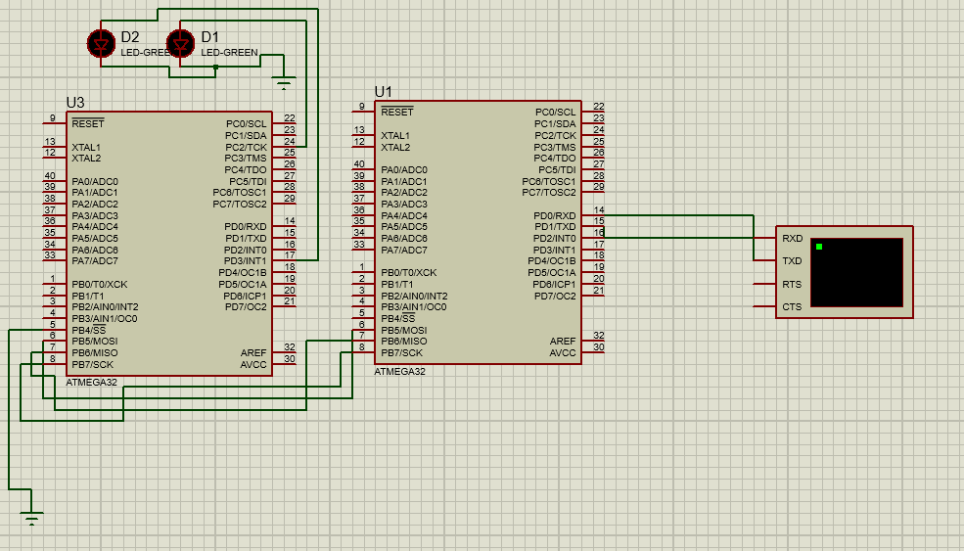

**Procedures:**

The Bluetooth module sends a command to MU1 using UART communication protocol then MU1 sends this command to MU2 using SPI communication protocol we use this command to toggle either LED1 or LED2 as following:

1. Command **“a”** toggle LED1.
2. Command **“b”** toggle LED2.